
Version 3.0
LAB MANUAL

Continuous Integration
with Jenkins

Table of Contents

1: Install Jenkins 5
2: Create a Jenkins Job 11
3: Scheduling a Jenkins Job 17
4: Secure Jenkins 23
5: Complex Jenkins Projects 27
6: Extending Jenkins Builds with Plugins 31
7: Distributed Build in Jenkins 33
8: Run NodeJS Plugin in Jenkins 39
9: Extending Jenkins 43
10: Build a Jenkins Pipeline in Code 47
11: Build a Jenkins Pipeline View 51

1: Install Jenkins

Overview
In this lab, you will install Jenkins and perform some initial setup to enable a job to run. The purpose of the lab is to demonstrate the broad range of options available when building and testing an application in Jenkins.

Jenkins, like other continuous integration servers, supports many types of build and test processes and needs access to many different technology pieces to run.

You will perform these general tasks:
- Install Jenkins
- Select Jenkins plugins to install
- Customize the Jenkins environment

- Download Jenkins from:

https://updates.jenkins-ci.org/latest/jenkins.war

Once the war file is available, Jenkins can be installed. Because it is an executable war, place the war in the folder where you want to install Jenkins.

  - Windows Location: C:\_jenkins
  - Mac Location: /Users/{yourUserName}/Jenkins

- Now set a system environment variable to JENKINS_HOME.

- Windows Option 1: Open the Windows command prompt as an administrative user and run the following command:
- setx JENKINS_HOME C:\jenkins_home
- After doing so, close the command prompt and then reopen the command prompt and issue an echo %JENKINS_HOME% command. This should print out C:\jenkins_home. The command prompt only reads system variables when it is first started, which is why the window needs to be closed.

- Windows Option 2: Open System in Control Panel and click Advanced System Settings. Click the Environment Variables button and click New to add a variable named JENKINS_HOME with a value of the location you installed Jenkins to in step one (C:\_jenkins). Click OK to close all the Control Panel dialog boxes that popped up.

- For Mac: Run the following command.
echo `export JENKINS_HOME=/Users/{yourUserName}/jenkins` >>~/.bash_profile
Or, you can use vi to enter the environment variable manually in the .bash_profile (vi .bash_profile).
The same change should also be made to the .bashrc which will also set the environment variables for sessions not associated with a terminal.

- The first time Jenkins is launched, it will create all the necessary content in the JENKINS_HOME folder. To perform the initial installation and configuration, run the command below:
java –jar jenkins.war

This will install Jenkins and allow Jenkins to run as a standalone application using Jetty as the servlet engine. The following traces will eventually show in the terminal/command window.

Jun 09, 2017 10:39:54 AM jenkins.install.SetupWizard init
INFO:

*************************************************************
*************************************************************
*************************************************************

Jenkins initial setup is required. An admin user has been created and a password
generated.
Please use the following password to proceed to installation:

760000000000000000000098

This may also be found at: C:\jenkins_home\secrets\initialAdminPassword

*************************************************************
*************************************************************
*************************************************************Apr 13, 2016 6:21:53 PM hudson.model.AsyncPeriodicWork$1 run
INFO: Finished Download metadata. 17,923 ms

- Test that Jenkins is running by opening a web browser to http://localhost:8080 and you will see:

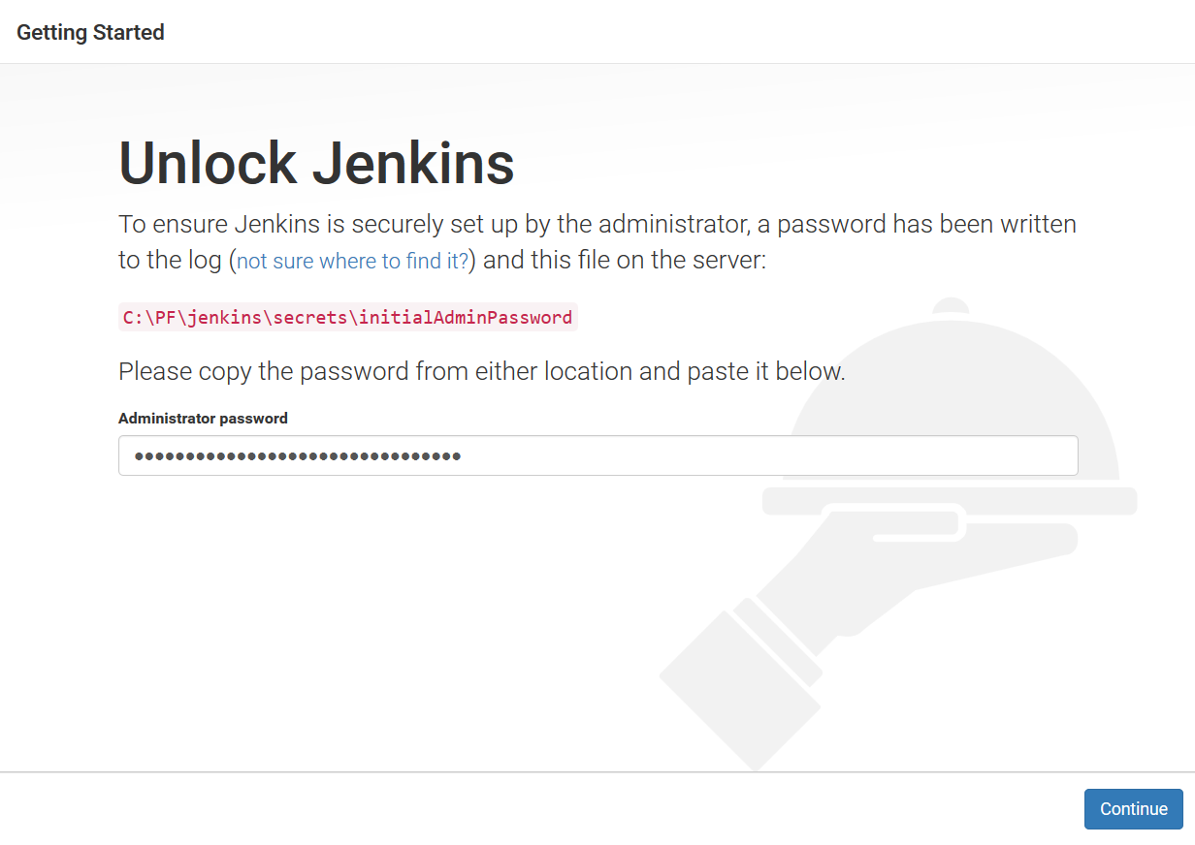

- Enter the password that was placed in the log or open the file in secrets/initialAdminPassword folder from step one.

- Select the Select Plugins to Install button. Scroll through the list and notice which ones are selected and which ones are not. This is an exploratory step. We are not going to do the initial setup from this screen. Click the Back button.

- Select the Install Suggested Plugins button. The screen will show the plugins that are being loaded and installed. A spinning circle indicates downloading and installing and a green checkmark indicates successfully installed. If the install fails there will be a red X. This happens and is not a concern. If there are errors loading plugins click the Retry button. It might take a time or two. Eventually all the plugins will have been installed successfully. The first User screen comes up where the first user is created.

- Define your first user by filling out the fields on the page. Click the Save and Finish button. You are now logged in as the user just created. Since this user is an administrator it is possible to configure the Jenkins environment.
Click: Start using Jenkins

- To customize the Jenkins environment, click the Manage Jenkins link. Security is initially enabled with Jenkins internal database and logged in users can do anything. We will discuss this more in the security unit.

- Click the Configure System link. Let’s change our Jenkins from the default settings and customize the System Message. Change it to something different like My Jenkins and click Save.

- This would also be a good time to set the admin email address. That is used to notify someone when the system is encountering issues. For Jenkins to send notification emails, it is necessary to set the SMTP Server information. This setting is nearly to the bottom, (under E-mail Notification not Extended E-mail Notification). If it is not set, then Jenkins will use the default server, localhost, if available.

- The CVS and Subversion support is installed with the initial Jenkins installation. The settings to connect to a repository need to be provided. We will not be using CVS or Subversion for this class, but this is where that definition would be done. We will be using Git, so we will come back to this screen in a later exercise after the Git plugin is installed.

- Save the settings by clicking the Save button. After changing system settings, it is a good idea to restart Jenkins. The easiest process is to go to the terminal window where Jenkins was started and to stop it by hitting Ctrl-C. Jenkins will stop. Next, start it again by running the same command that started it earlier. Finally, using a cursor up key, scroll up to the previous command and hit Enter.

Optional: Install Jenkins on Tomcat

- Stop Jenkins again. We will now configure Jenkins to run in a servlet container. We will be using Tomcat 8. It is very easy to get the Jenkins running in Tomcat.

- Find the Apache Tomcat 8.0 installation location and copy the jenkins.war to deploy Jenkins to the Tomcat.

- For Windows:
- On the command line type set CATALINA_HOME to find where on the PC Tomcat is installed.
- Or find the program Apache Tomcat 8.5 → Monitor Tomcat and Start Tomcat 8.5.
- Copy the jenkins.war file from the location you used in step two to the webapps folder of the Tomcat 8.5 installation location. You can see it in the Monitor Configuration popup.

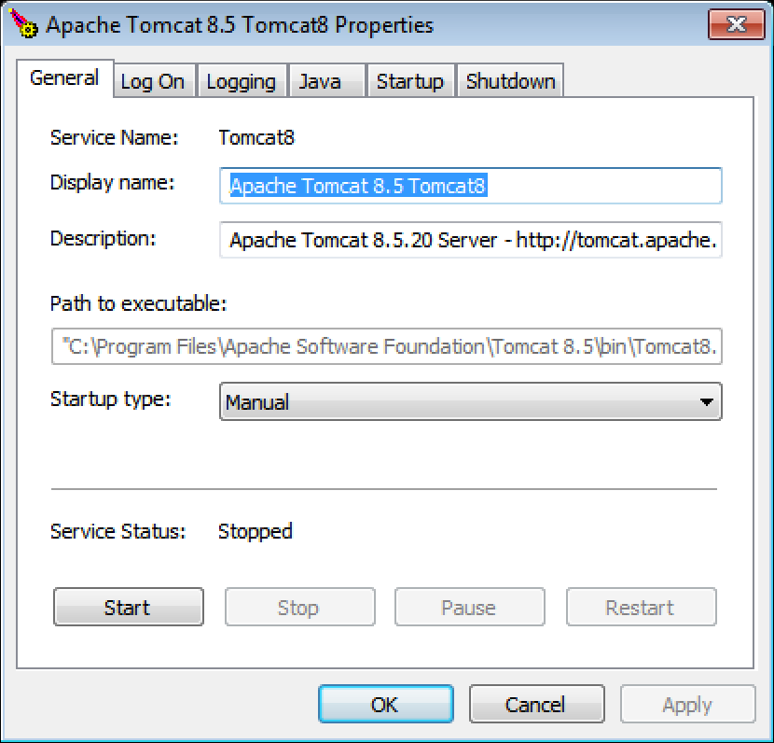

- For Mac: type echo $CATALINA_HOME in a terminal window to get the folder location. If no folder is returned, the system requirements/setup document says to create a symbolic link as /Library/Tomcat. You can use that as the Tomcat installation location. Copy the jenkins.war file from the location you used in step two to the webapps folder of the Tomcat 8.5 installation location.

- It will take a moment to deploy Jenkins. Once Jenkins has deployed to Tomcat, open it by using the URL http://{yourHostName}:8080/jenkins and you will see the Jenkins home page.

- Verify that the settings were preserved by looking at the system message and verifying the message you set in System Message is displayed.

- Since we deployed Jenkins to a servlet container, the URL is now changed. From the main Jenkins page, click on Manage Jenkins. Click on Configure System. Scroll down to the Jenkins Location and change the URL to include /Jenkins at the end. It should look something like: http://{yourHostName}:8080/jenkins which will be very important when users try to respond to emails or links generated by Jenkins which will include a URL.

Troubleshooting Notes:

When you try to start Jenkins in Tomcat, you could encounter an issue where Tomcat will start but is unable to deploy Jenkins. The symptoms are that you see the Tomcat home screen at http://localhost:8080 but get a 404-error at http://loclahost:8080/jenkins.

- Make sure you have Tomcat and Jenkins shut down before you copy the jenkins.war to the webapps directory.

- You may have to change the environment variables to an 8dot3 style, such as:

C:\progra~1\apache~2 instead of:
C:\program files\apache-tomcat-8.0.33.

2: Create a Jenkins Job

Overview
In this lab, you will create an instance of a job in Jenkins. The purpose of the lab is to demonstrate the broad range of challenges that are presented when building and testing an application.

Jenkins, like other continuous integration servers supports many types of build and test processes and organizes them under Jobs. Jenkins uses Plugins to support the many additional features needed to support different technologies and environments required for building applications of all sorts.

This job will be a very simple job that:
- Copies a set of Java classes and JUnit tests to the Jenkins workspace
- Builds the project using Maven

To accomplish this, you will perform these tasks:
- Configure and install Maven and its dependencies
- Define and configure a new Maven Job
- Copy the provided simple-app project consisting of a Java class and Junit test
- Run the Build and view the results
  - Compiles the Java classes and the Test classes
  - Executes the unit tests
  - Installs the artifact into the Maven local repository

- The Jenkins server should already be running. Open the browser of your choice and navigate to the Jenkins URL. It should be http://localhost:8080 by default, unless it was configured for another port.

- We are going to build a Maven project. Since this is our first job and Maven isn’t initially configured, that is our first task. Click on the Manage Jenkins link. Then, click on Global Tool Configuration to open the tools configuration settings screen.

- Scroll down to the JDK settings and add a new JDK by clicking the Add button.
  - Name it JDK 8.
  - Uncheck the Install automatically checkbox.
  - Set JAVA_HOME to the location of your installed JDK. It must be a JDK not a JRE. Confirm the actual location of the JRE on your own system as JDK versions may differ from one environment to the next.
  - For Windows: C:\Program Files\Java\jdk1.8.0_NN
  - For Mac:
/Library/Java/JavaVirtualMachines/jdk1.8.0_NN.jdk/Contents/Home
(Replace NN with the version number of Java installed on the machine.)

If your JDK is somewhere else, you can find the JAVA_HOME by the following commands:
- For Windows in a Command window: set JAVA_HOME
- For Mac in the Terminal: echo $JAVA_HOME

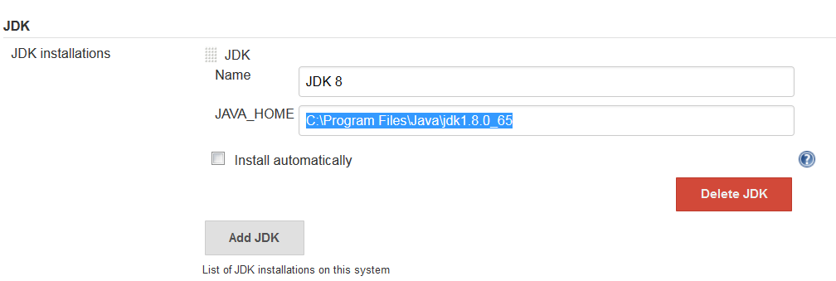

- Next configure Maven. Click the Add button to add a new Maven installation. Name it Maven 3.3.9 and leave 3.3.9 selected in the dropdown. Also keep Install automatically checked so that when the build requires a Maven instance, it will be installed in the tools folder of Jenkins and also in the nodes when it runs in a node.

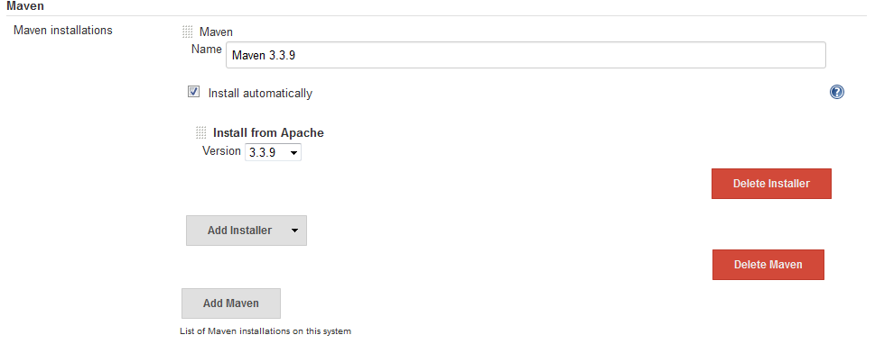

- Click the Save button at the bottom of the screen.

- Define a new Freestyle job which will be used to build a simple Maven archetype job for a Java application. It was created using Eclipse. This job will use the Maven project, which is widely used in the industry.
  - Click New Item to begin defining the new job and name it: simple-app
- Note: It is a good practice not to use spaces or non-alphanumeric characters in the project name. Some plugins have been known to have issues with projects that have a space in the name in the past. It doesn’t happen as frequently anymore.
  - Select Freestyle project.
  - Click the OK button.
  - Click the Save button.
  - Click the Back to Dashboard link.

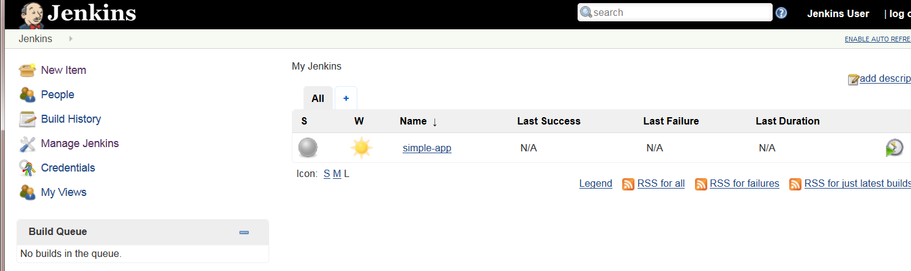

- Click the link to open simple-app. Click the Configure link to open the configuration settings for the simple-app job. The screen opens the job on the General tab.

- Select the Add build step dropdown and select the execute command appropriate for your environment.
  - For Windows: Execute Windows batch command
  - For Mac: Execute shell

- A simple-app project is provided in the Setup.zip archive that was provided with the course materials. This project has a Java class that is simply a Hello World application. It also contains a JUnit test case.

Enter the command to copy the folder simple-app from the Setup folder, which should be C:\Setup for Windows or the users home folder/Setup for Mac. The syntax to do this is below:
- For Windows: xcopy /S /Y c:\setup\simple-app\* %WORKSPACE%\*
- For Mac: cp -r ~/setup/simple-app/ .
Make sure there is a space between simple-app/ and the dot

- Add another build step and select Invoke top level Maven targets. For the Maven Version select Maven 3.3.9 from the dropdown. For Goals: Enter into the text field: clean install.

- Select the Add post-build action dropdown and select publish JUnit test result report. Enter target/surefire-reports/*.xml in the field Test Report XMLs.

- Click the Save button. Build the project by clicking the Build Now link.

- The build will start and run for some time. Eventually the build will finish and there will be a blue ball by the #1 under the Build History. Each build will increment and be available in the build history. Click the #1.

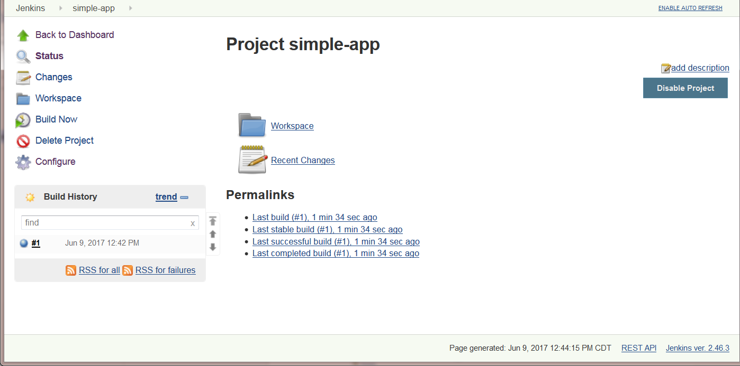

The Build Details screen will appear.

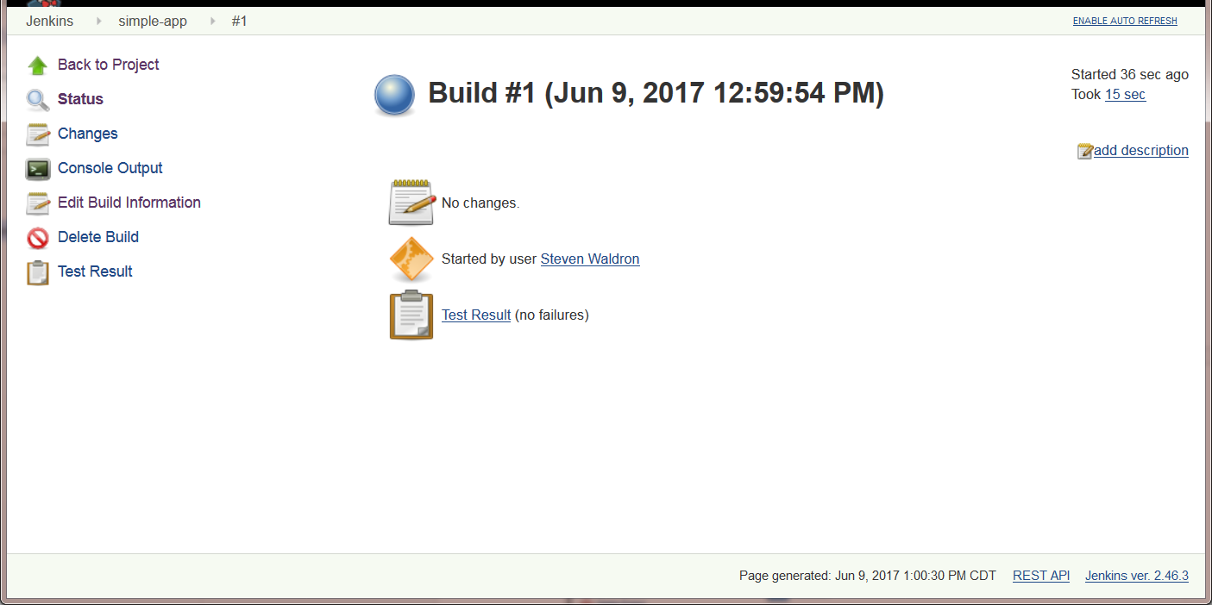

- Click the Console Output. This displays the log of how the build was accomplished.

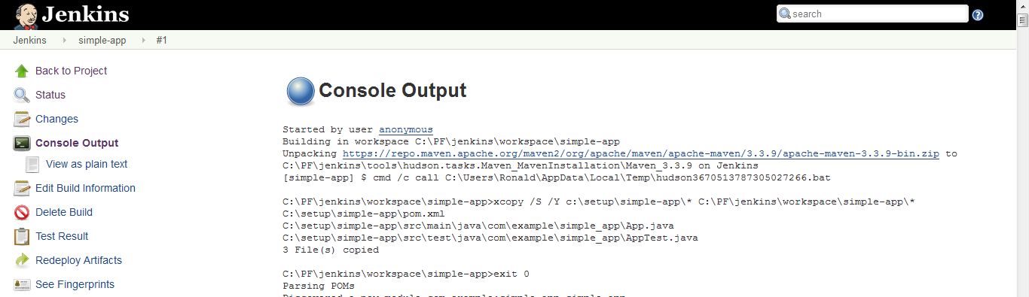

When you scroll all the way down, you should see a Build SUCCESS message.

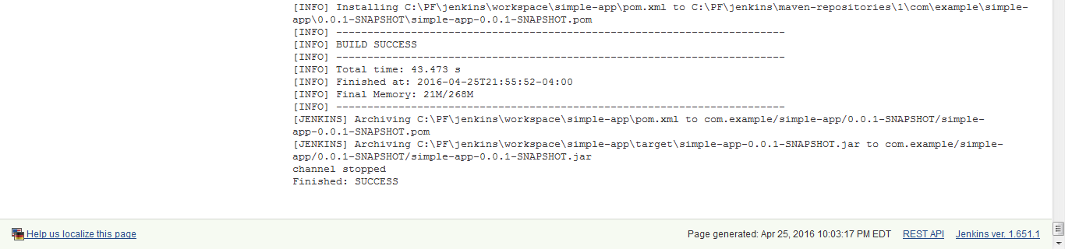

- Click the Test Result link. This displays the results of executing the test cases.

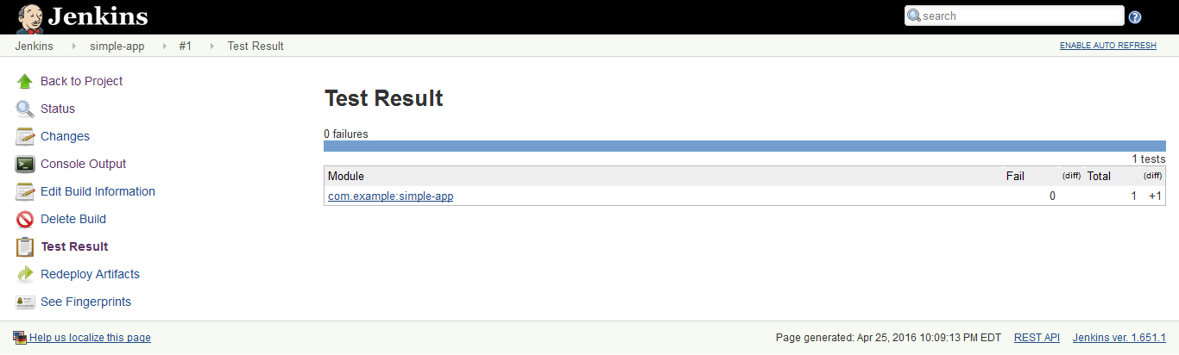

- Click the Changes link. This will display No Changes because this project is not associated with any Version Control System.

3: Scheduling a Jenkins Job

Overview
In this lab, you will schedule a job to run when various events happen.

To accomplish this, you will perform these tasks:
- Use Eclipse to import the provided Cucumber project from a Git repository
- Use Jenkins to define a new Freestyle job named schedule-app
- Configure the schedule-app job to specify the schedule and the repository location
- Run the job and examine the results
- Make a code change in Eclipse and watch the build run on schedule

- Shut down any running instance of Tomcat or Jenkins, and then restart Jenkins using the java -jar jenkins.war command
- The Jenkins server should already be running. Open the browser of your choice and navigate to the Jenkins URL. It should be http://localhost:8080/ by default, unless it was configured for another port.

- First, using Eclipse, you will import a project from Git.
  - Open Eclipse and click File → Import…
  - When the dialog pops up select Existing Maven Projects under Maven and click Next.
  - Click Browse… and navigate to:
  - For Windows: C:\setup\git\cuctest
  - For Mac: /Users/yourUserName/Setup/git/cuctest
  - Click OK or Open. Check the Project and click Finish.

The project will be imported. On the file system, navigate to the project and examine the contents of the cuctest project.

- Back in Jenkins, you will define a new Freestyle job.
  - Select Create new Jobs link to begin defining the new job.
  - Name the project schedule-app. Again, it is a good practice not to use spaces or non-alphanumeric characters in the project name.
  - Click the OK button.
  - Click the Back to Dashboard link.

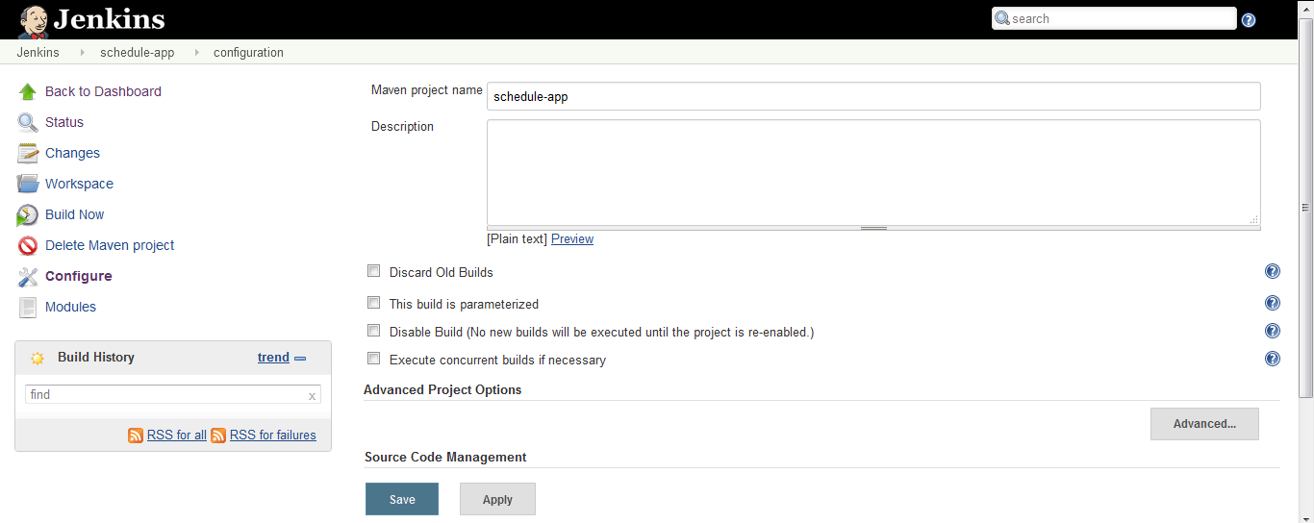

- Next, we will configure the schedule-app job. Click the link to open schedule-app. Click the Configure link to open the configuration settings. There are many settings that can be set to control the build process. The ones that we are going to set are the schedule and the repository location.

- Now, you will associate the job with the Git repository. To do this, scroll down to the Source Code Management section. Select the Git radio button. (If you don’t see the Git radio button look at the end of this lab under troubleshooting tips on how to solve this.) This will open up settings to allow mapping the job to a Git repository. Set the location to:
- For Windows: C:\Setup\git\cuctest
- For Mac: /Users/yourUserName/setup/git/cuctest

Clicking the Advanced button will allow specifying more detailed control over how Git repository mapping is managed. The Advanced settings are not applicable to this exercise since this is a local repository with no remote.
- Select the Poll SCM radio button under Build Triggers to enable the schedule field. This is where the frequency of polling is defined. It is a cron style format. To find out appropriate values click the ? to the right of the field.

We will use H/5 * * * * to specify that it will be every 5 minutes hashed randomly based on the job name. The H on the front will make jobs with the same 5-minute interval not start at the same minute.

- Select add build step and select Invoke top-level Maven targets. For the Maven Version select Maven 3.3.9 from the dropdown. For Goals: Enter into the text field: clean install.

- Add a Add post-build action and select publish JUnit test result report. Enter target/surefire-reports/*.xml in the field Test Report XMLs. Save the configuration. Click Save.

- Navigate to the main page. Keep refreshing the page for about 5 minutes and eventually the Executor will poll the SCM and find that there was a change. When the blue ball appears indicating a build has completed, select the #1 link to see the results of the build.

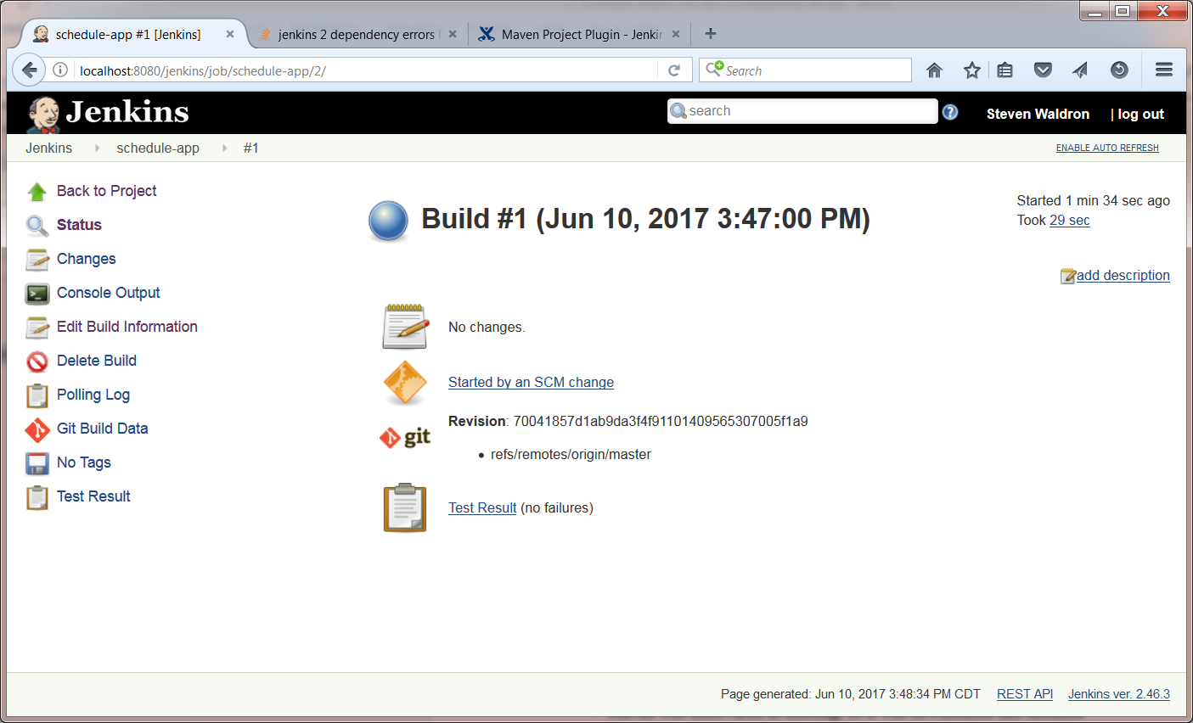

- Things to notice in the build:
- Triggered by SCM change
- Git retrieved content
- Maven was discovered as missing, so it was downloaded and installed
- Maven parsed pom.xml
- Downloads for all the dependencies
- Cucumber tests run 5 total, 3 skipped (Click on Test Result to see this.)

- Now we will update the Stepdefs.java in Eclipse.
  - In Jenkins, click on the schedule-app and on the #1 next.
  - On the left, click on Console Output.

  - When you scroll down you will see the following text. Copy the snippets from the browser into Eclipse to Stepdefs.java.

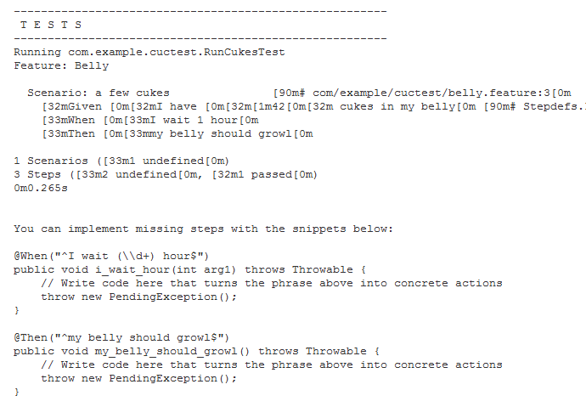

  - Eclipse will show some code errors because some import statements are missing. To fix that you will need to add (organize) the imports.
  - For Windows: ctrl+shift+O
  - For Mac: ⌘+shift+O

  - Save the file and commit.
    - Access the project's context menu in Eclipse. (Right-click the project on Windows or Control+Click the project on Mac.) From the project's context menu, select Team → Commit.
    - In the tab Git Staging:
Add the comment Add the missing test cases and click Commit.

- Wait for a few minutes until the interval triggers a build.

- Notice that the build triggered and the missing test cases were run. Since there was not a valid implementation of the methods, there will be a message indicating that there is still work to be done. However, the goal of this exercise was to configure a job that builds on a schedule and automatically integrates code changes. You have accomplished the continuous integration for the build.

Troubleshooting Tips:

- If you don’t see the Git radio button, you do not have the Git plugin installed.
- Click on the Jenkins link in the left top corner
- Click Manage Jenkins → Manage Plugins
- Click the Available tab and type Git plugin and check the box to the left of it
- And click Download now and install after restart
- Restart Jenkins

4: Secure Jenkins

Overview
In this lab, you will configure the security settings in Jenkins to prevent unauthorized access to the Jenkins build machine. Enabling security is an industry best practice.

First, you will start with a Jenkins environment which has been secured so you will disable security and will explore the various options for securing Jenkins. Then, you will secure the environment using the built-in Jenkins database. Initially you will enable authentication, and later you will add authorization for full or limited access.

The general steps are:
- Disable security
- Enable security
- Self-register a user
- Assign user privileges
- Self-register a different user
- Give users different privileges
- Switch users and notice what is permitted

- If not already running, start Jenkins using the jenkins.war file with the following command:
java -jar jenkins.war

- Open the Jenkins URL http://localhost:8080 to see the main Jenkins page.

- Security is automatically enabled for Jenkins now. Notice the username in the top left of the Jenkins screen. There is also a logout link. To see how Jenkins looks without security, we will first disable security. From the main Jenkins page, click Manage Jenkins. Click on Configure Global Security. On the Configure Global Security page uncheck the box next to Enable Security. Click Save. Notice that the title bar of the page no longer has a user name listed.

- A number 1 in a big red box will appear on the screen. Click the 1 and read the error message. This is a message indicating that security is no longer enabled and it is bad practice to run Jenkins without a security context. You can click the Setup Security link which will take you to the Configure Global Security page.

- The Configure Global Security page has only a couple of items to choose until the Enable Security checkbox is checked, so check it now. That will enable options for securing Jenkins. Click on Jenkins own user database radio button. Click on Allow users to sign up to enable that feature.

- Under Authorization, click the radio button to select Logged in users can do anything. Later we will change the security settings, but this is a starting point for now.

- Save the configuration and Jenkins will reload the main Jenkins screen with you logged back in. Click to log out.

- Save the configuration and Jenkins will reload the main Jenkins screen, but this time with security features enabled. Log in and sign up links are now available and there is a place to enter login credentials. However, before anyone can log in as a user, they must sign up.

- To enable credentials to log in, first sign up. Click the sign up link.

Fill in the fields as shown below:

Username: admin
Password: secret
Confirm Password: secret
Full Name: Jenkins User
E-mail address: jenkins.user@example.com

- Click the sign up button and Jenkins will redirect to a page with confirmation that you are now logged in. The user name displays in the top right corner. Next to that is a log out link to allow the user to log out. Clicking the link to the top page will take the user back to the main Jenkins page.

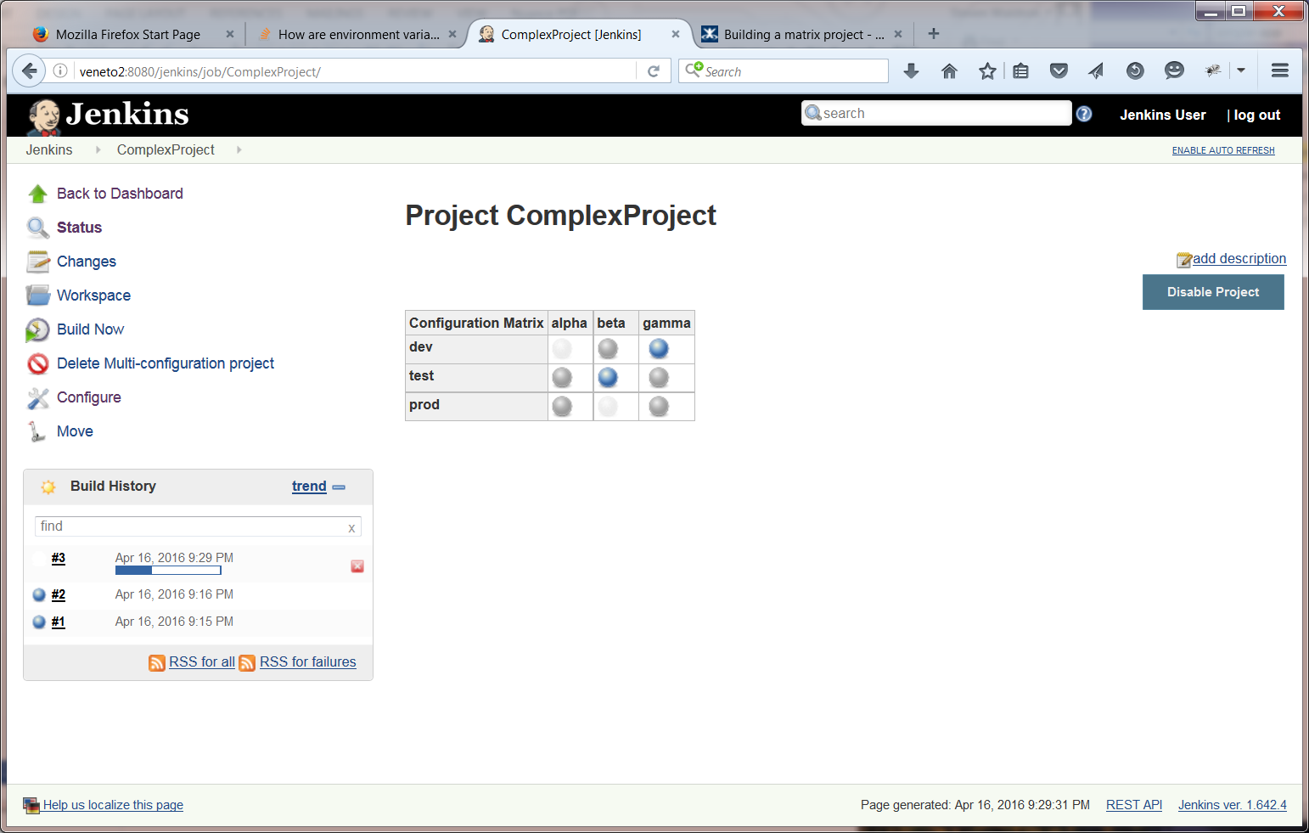

- Click the Manage Jenkins link and the Configure Global Security link to reconfigure security now that there is a user.

Click the radio button for matrix-based security and add the user just created with all permissions. To do that, enter admin in the User/group to add field and click the add button. The user will be added to the matrix.

Click the icon next to the red box with an X on it that resembles a notebook page with a checkmark on it. All the permissions are now checked. For anonymous, select Read in the Overall section, Read under the View section, and Read under the Job section. Hovering over the permission with a mouse will pop up the details regarding the permission. Click Save to make the changes active.

- Log out of Jenkins. Register a new user:

Username: ouser
Password: secret
Confirm Password: secret
Full Name: Ordinary User
E-mail address: ordinary.user@example.com

- Save the user. This ordinary user does not have the ability to create jobs, but can view jobs.

- Log out and log back in as ouser and notice that the user has only limited functionality.

- Log back in as admin and notice that full functionality is available.

You have now enabled authentication and authorization in Jenkins.

5: Complex Jenkins Projects

Overview
In this lab, you will create an instance of a job in Jenkins that includes more than just simple Java projects. You will use Jenkins to configure a job with a configuration matrix to build a complex project.

The general steps are:
- Create a multi-configuration project
- Define the configuration matrix
- Add a build step to execute a Windows batch command or (Mac shell)
  - Output the configuration parameter values for each iteration
- Build the project
- View the results

- The Jenkins server should already be running. If it is not running, start the CI tool using the java -jar jenkins.war command.
- Open the browser of your choice and navigate to the Jenkins URL. It should be http://localhost:8080 by default, unless it was configured for another port.

- Define a new job to copy a file from one folder to another. This job will use the Multi-configuration project. There are other choices available, but to begin with, this is the most common project type for generic build processes. (Note: If your organization is already using Maven, then that would be used by your team.)
- Select the New Item link to begin defining the new job.
- Name the project ComplexProject. Select the Multi-configuration project radio button and click OK.
- Click the Save and Back to Dashboard links.

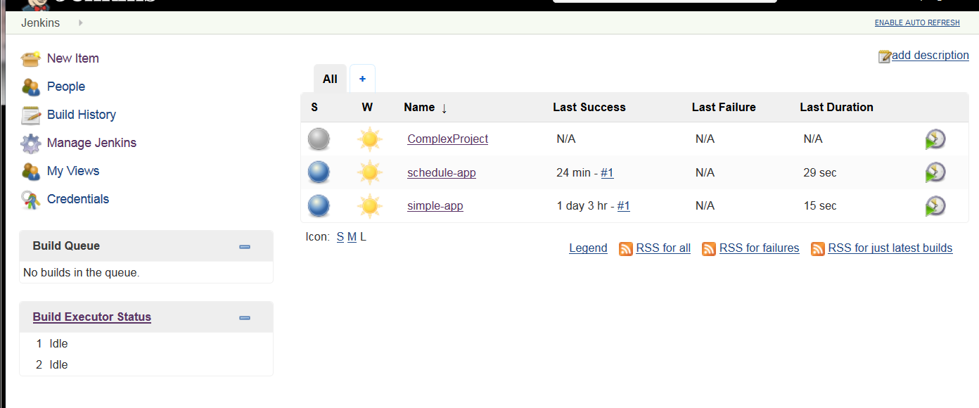

- Click the ComplexProject link and then the Configure button.

- Scroll down to the Configuration Matrix. Click Add Axis and select User-defined axis. Enter target for the name. For the values, enter alpha beta gamma.

- Add another axis named releaseenv with values dev test prod.

- Scroll down to the Build and add a build step.
  - For Windows: execute windows batch command and add the lines:
- echo %target%
- echo %releaseenv%
- For Mac: execute shell and add the lines:
- echo ${target}
- echo ${releaseenv}

- Click the Save button.

- Click the ComplexProject project link.
  - Click the Build Now link. The build will run for a few seconds and the Build History will update with the timestamp of the build and a blue icon indicating a successful build.
  - The matrix will update as the jobs are executed and the balls will turn from grey to blue:

  - Click the #1 build link in the Build History.

  - Click the arrow next to the blue ball at the intersection of dev and alpha. Click the Console Output link.

The console output should look similar to this (it will look slightly different on Mac):

Started by upstream project "ComplexProject" build number 1
originally caused by:
Started by user Jenkins User
Building in workspace C:\Users\Commander\.jenkins\workspace\ComplexProject\releaseenv\dev\target\alpha
[alpha] $ cmd /c call "C:\Program Files\Apache Software Foundation\Tomcat 8.5\temp\jenkins7497962599531974714.bat"
C:\Users\Commander\.jenkins\workspace\ComplexProject\releaseenv\dev\target\alpha>echo alpha
alpha
C:\Users\Commander\.jenkins\workspace\ComplexProject\releaseenv\dev\target\alpha>echo dev
dev
C:\Users\Commander\.jenkins\workspace\ComplexProject\releaseenv\dev\target\alpha>exit 0
Finished: SUCCESS

  - Notice in the console that the user is now set on build. That is because security has been enabled for Jenkins. That will be important to track which users have contributed code that caused the builds to fail.
  - Click the Back to Project link twice.
  - Click the Back to Dashboard link.

6: Extending Jenkins Builds with Plugins

Overview
In this lab, you will enhance the Jenkins build process by installing Plugins and adding them to jobs.

Some very useful plugins for a continuous integration improvement process are FindBugs and JaCoCo. It is easy to improve the quality of code by adding these to the build process to get a better understanding of the overall quality of the code. This lab will show how easy it is to add that functionality to the build process.

You will perform these tasks:
- Install several plugins for code quality
- Create a new Maven project named simple-app2
- Add a pre-build step to copy the provided application from the setup folder
- Configure the build to use the plugins
- Add post-build steps to produce the code quality reports
- Build the project
- View the code quality reports produced

- The Jenkins server should already be running. Open the browser of your choice and navigate to the Jenkins URL. It should be http://localhost:8080 by default, unless it was configured for another port.

- Click on Manage Jenkins → Manage Plugins.

- Click on the tab Available. In the search field, enter Checkstyle. Check the checkbox to the left of the Checkstyle Plug-in.

- Repeat the above step for the following plugins.
- Maven Integration plugin
- FindBugs Plug-in
- PMD Plug-in
- Static Analysis Collector Plug-in
- JaCoCo Plug-in

- After checking the checkbox by all the plugins listed above, click the button labeled Download now and install after restart. While none of these have been installed before and it is safe to install without restart, it is almost always better to restart after installing plugins. Wait for the plugins to download.

- Restart Jenkins.

- Go back to the Jenkins main page.
- Create a New Item. Name it simple-app2. Notice there is now a Maven Project. That is because we added the plugin with support for Maven projects as it used to be core in version 1 but is not core in version 2. Use the Maven project. Click OK.

- Configure the new item just created by clicking the link simple-app2 and then clicking Configure.

- Select the Add pre-build step dropdown and select the execute command appropriate for your environment.
For Windows: Execute Windows batch command
For Mac: Execute shell

- Enter the command to copy the folder simple-app2 from the course setup folder, which should be C:\Setup for Windows or the user's home folder/Setup.

Syntax:
For Windows: xcopy /S /Y c:\setup\simple-app\* %WORKSPACE%\*
For Mac: cp -r ~/setup/simple-app/ . ← Note the space and dot!

- Scroll down to the Build and under Goals and options enter:
clean install pmd:pmd findbugs:findbugs checkstyle:checkstyle site

- Scroll down to the Build Settings. Check the checkboxes by the Publish the Checkstyle analysis results. Do the same for FindBugs and PMD. Checking the checkboxes triggers the plugins to be run on the next build.

- Add a Post-build Action to Publish combined static analysis results. This plugin will aggregate the results from the PMD, FindBugs and CheckStyle plugins into a single report.

- Add a Post-build Action to add Record JaCoCo coverage report. The JaCoCo coverage report will use the results of the unit tests of the application to determine the percentage of code being covered by test cases.

- Save the configuration. Click the Build Now button. The build will take a bit longer this time as there is much more to the build process.

- Eventually the build will finish. Click the Status link or click the simple-app2 link near the top of the page (like a header with breadcrumbs).

- Click the PMD Warnings. There are duplicate imports and unused imports. Both are yellow as they are not considered terribly bad. Click the Details tab and the code will be displayed.

- Click the FindBugs Warnings. There are three warnings regarding useless code. Click on the Details tab and see where the useless code is.

7: Distributed Build in Jenkins

Overview
In this lab, you will create a distributed build system and execute jobs on the node.

To do this, you will perform these tasks:
- Ensure Jenkins is running
- Define a Dumb Slave node
- Define a new Maven job named distributed-app
- Configure the build schedule and repository location
- Restrict the job to run only on the node you defined earlier
- Configure additional job settings
- Run the job and review the results

- Ensure that Jenkins in running. If not, issue the following command to start the CI tool: java -jar jenkins.war

- Test that Jenkins is running by opening a web browser to http://localhost:8080 and you will see the Jenkins home page with the Welcome screen.

- We will be launching our nodes using Java Web Start but in version 2 of Jenkins the option is off by default, so we will need to turn it on. Click the Manage Jenkins link. Click the Configure Global Security link. On the Configure Global Security page, check the Fixed radio button for TCP port for JNLP Agents. Enter port 50724 if that port is available on your host. See the troubleshooting section if you are not sure if the port is available.

- In order to configure jobs to run on nodes, the nodes need to be defined. Go back to the Jenkins main Page. Click the Manage Jenkins link. Click the Manage Nodes link.

- This screen is where master and slave configuration is managed. Clicking on the master shows there has been no activity on the master yet. Click the back button on the browser and click the New Node link. Name the new node JenkinsNode1. Select the Permanent Agent radio button and click OK.

- This screen is where the details of the slave are defined.
  - Set the remote root directory.
  - For Windows: C:\PF\JenkinsNode1
  - For Mac: /Users/YourUserName/JenkinsNode1
Set the Launch Method: Launch Slave agent via Java Web Start

  - Click Save which will take you to the Manage Nodes page. Click the node just created. On the next screen click the Launch button.

Note: If prompted to install a later version of Java, skip the install if there is already Java installed.

  - This will download a slave-agent.jnpl application.
  - For Windows: This application should start automatically. If not, start it manually.
  - For Mac: This application will not start automatically.
  - Click on Downloads and select Show in Finder.
  - Control-click and select Open.

  - Click Run and eventually an agent will pop up. This is running a Jenkins node agent. Keep it running so Jenkins can route jobs to it.

- If that fails, the service can be run from the command line or launched from Jenkins when needed. To run from the command line, go to the directory of the node and enter the command displayed in Jenkins for the node.

- Define a new Maven job to build a simple Maven archetype job for a Java application. It was created using Eclipse. This job will use the Maven project.
  - Select the Create new Jobs link to begin defining the new job.
  - Name the project distributed-app. Again, we are avoiding spaces or non-alphanumeric characters in the project name.
  - Click the Save button.
  - Click the Back to Dashboard link.

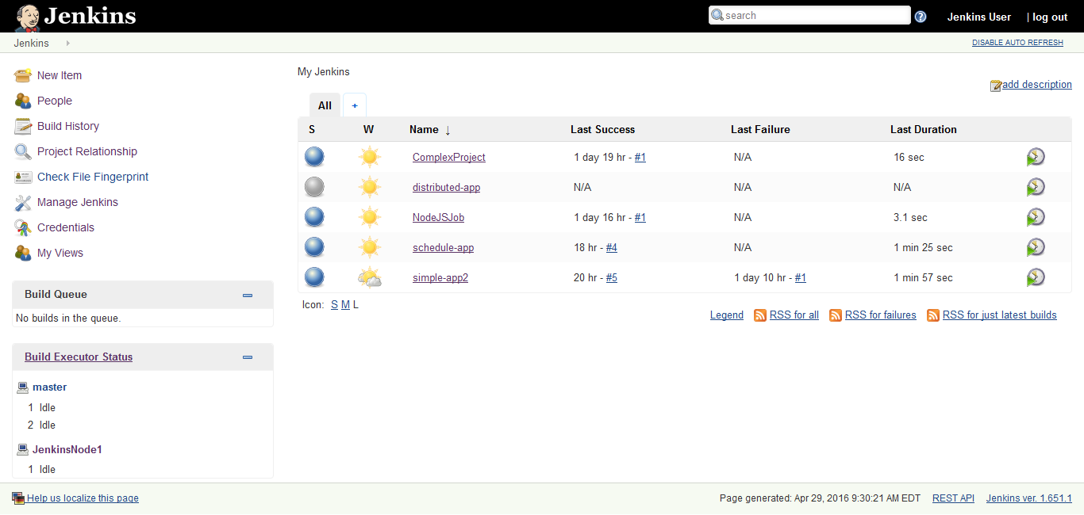

- Click the link to open distributed-app. Click the Configure link to open the configuration settings. There are many settings that can be set to control the build process. The ones that are going to be set are the schedule and the repository location, as we did in an earlier exercise. The next step will be familiar.

- First, you will associate the job with Git repository.
  - Scroll down to the Source Code Management section.
  - Select the Git radio button. This will open up settings to allow mapping the job to a Git repository.
  - Enter the Repository URL
  - For Windows: C:\Setup\git\cuctest
  - For Mac: /Users/YourUserName/setup/git/cuctest/

- Find the setting for Restrict where this project can be run and check the box. In the entry field, type the name of the node you created earlier: JenkinsNode1.

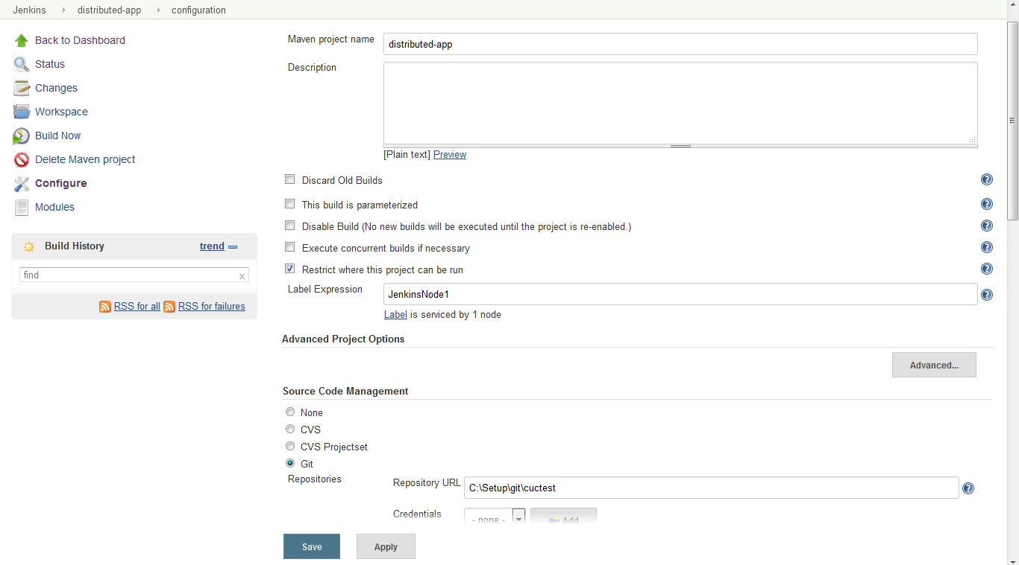

- Set the Maven version to use to Maven 3.3.9 in the dropdown. Set the goal to package.
  - Scroll to Pre Steps and click Add pre-build step
  - Select Invoke top-level Maven targets
  - Set Maven Version to Maven 3.3.9
  - Set Goals to package

- Save the changes.

- Run the job. Notice that it did not run on the master. It ran on the node. If the master is not busy it would normally have picked up the job and run it.

- Review the logs. Notice that Maven was downloaded for use by the node. Even though the master and the slave are on the same machine they do not share the same tool folders. They also do not share the same repository.

Beginning of the log:

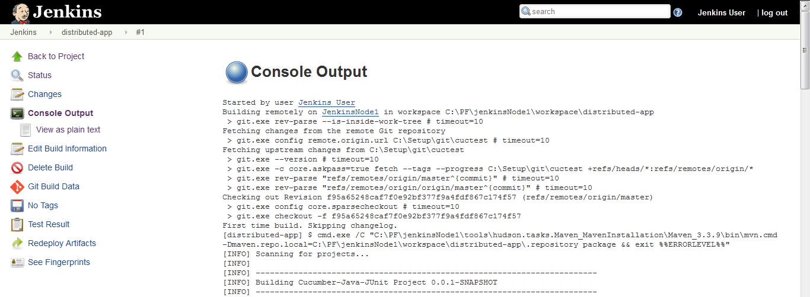

End of the Log:

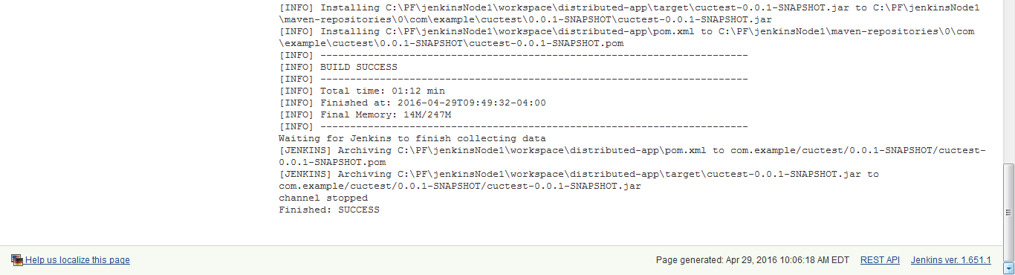

Troubleshooting:

Port for JNLP may not be available. Use the command line netstat –a > ports.txt and open the ports.txt file created to see if the port is listed in the file.

8: Run NodeJS Plugin in Jenkins

Overview
In this lab, you will use Jenkins to perform a build using the NodeJS environment.

NodeJS works much better on Linux than on Windows or Mac. They really only support one version of NodeJS per build. It is necessary to change the PATH for each build to support multiple versions of NodeJS. For developers, this should not be a problem.

The general steps that you will perform are:
- Install the NodeJS plugin and configure it
- Create a Freestyle job named NodeJSJob
- Add a build step to display the versions in use
- Add a NodeJS script build step to write to the console the build number and current working directory path
- Build the job and view the output to verify NodeJS is working in Jenkins

- Test that Jenkins is running by opening a web browser to http://localhost:8080 and you will see the Jenkins home page.

- To enable Jenkins to use NodeJS, the plugin must be installed. Click on Manage Jenkins to get to the management screens. Click the Manage Plugins link to view the page that allows plugins to be added and updated.

- Click on the Available tab, search for NodeJS and then check the box by NodeJS. Click the Install without Restart button to install it.

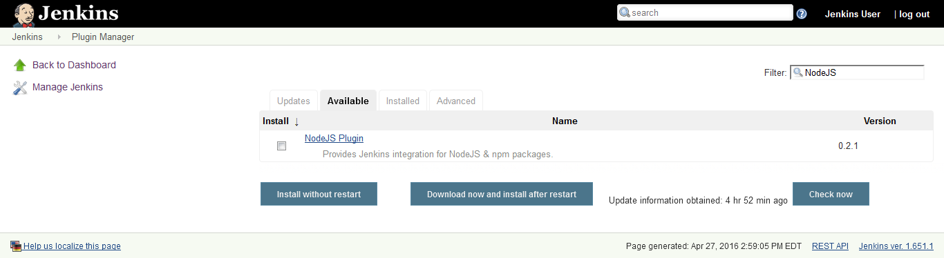

- After the install completes, go back to the Manage Jenkins page.

- In this step, you will configure the plugin to point to the installed NodeJS. To do this:
  - Click the Global Tool Configuration link.
  - Scroll down to the NodeJS.
  - Click Add NodeJS.
  - Set the name to NodeJS as there is only one for now. Set the installation directory to the location used during setup; (unclick Install automatically if necessary).
- For Windows: C:\Program Files\nodejs
- For Mac: /usr/local

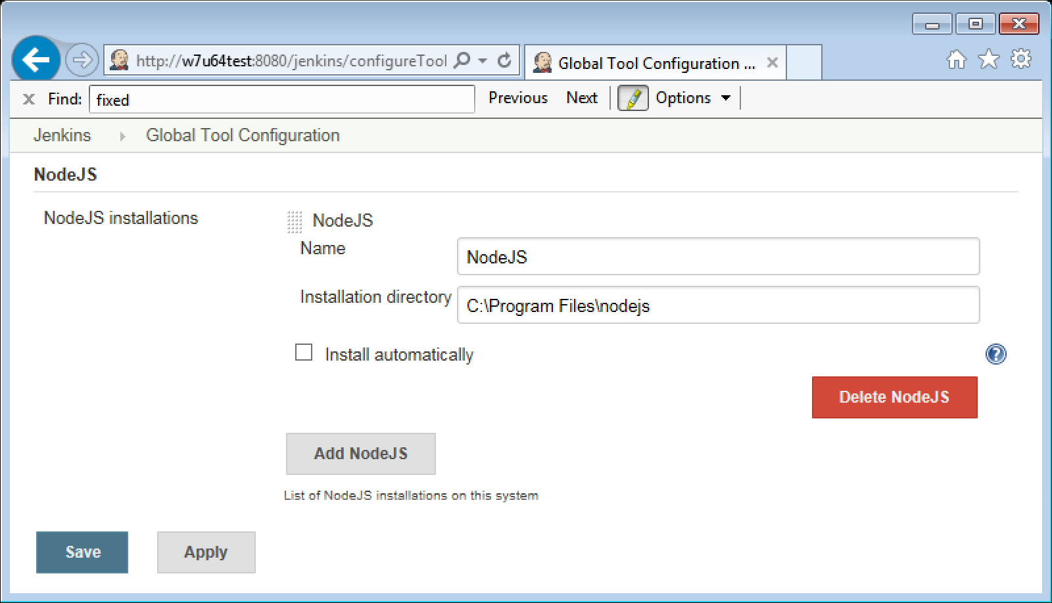

  - Save the configuration changes.

- Now, we want to add a step to display the versions in use so that we know NodeJS is working in Jenkins. To do this, create a new job named NodeJSJob and set it to a Freestyle job.

Then, add a build step for Execute Windows batch command or a Mac execute shell and add the following lines:
node --version
bower --version

- Add another build step. Select Execute NodeJS script and add the following lines:
var console=require('console');
console.log(process.env.BUILD_NUMBER);
console.log('current directory' + process.cwd());

- Save the changes and test the job. You should get the Finished: Success preceded by a build number and the current working directory path. This confirmed that the NodeJS plugin is working in Jenkins.

Troubleshooting:

If you receive the following error: %1 is not a valid Win32 Application when running the job on Windows, the work around is to create a bin folder in the NodeJS installation folder and copy the node.exe from the root of the NodeJS install folder to the bin folder.

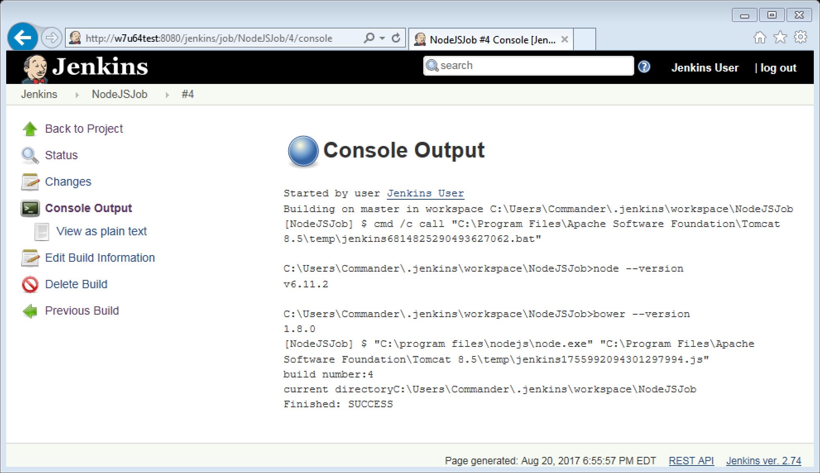

9: Extending Jenkins (Optional)

Overview
In this lab, you will extend Jenkins by writing a Jenkins plugin. Jenkins plugins are like Ant and Maven plugins. They are implementation classes that attach to extension points in the Jenkins environment. They have access to contexts of Jenkins and the job currently running as well as other plugins running within the job.

To accomplish this, you will perform these tasks:
- Configure and install Maven and Jenkins connection to repositories
- Create a Jenkins plugin Maven project
- Build the Jenkins plugin Maven project
- Test/use the new Jenkins plugin
  - Copy the Jenkins plugin to enable it in Jenkins
  - Restart Jenkins to enable reloading configurations
  - Create a new job and set the property on the build
  - Configure the builder global setting

- Add the Jenkins profile to your settings.xml file; use the user-specific settings.xml in the {user.home}/.m2.
- There is a snippets file (9 – Snippets.txt) in the setup folder with the profile below, if you wish to copy and paste.
- If you don’t have a settings.xml in your {user.home}/.m2 folder, create the file and use the settings.xml template in the snippet file.

<profile>
<id>jenkins</id>
<activation>
<activeByDefault>true</activeByDefault> <!-- change this to false, if you don't like to have it on per default -->
</activation>
<repositories>
<repository>
<id>repo.jenkins-ci.org</id>
<url>http://repo.jenkins-ci.org/public/</url>
</repository>
</repositories>
<pluginRepositories>
<pluginRepository>
<id>repo.jenkins-ci.org</id>
<url>http://repo.jenkins-ci.org/public/</url>
</pluginRepository>
</pluginRepositories>
</profile>

- Add the following mirror to the settings.xml file (also in the snippets file).

Note: There is usually a commented-out section in the XML file where the mirror goes.

<mirror>
<id>repo.jenkins-ci.org</id>
<url>http://repo.jenkins-ci.org/public/</url>
<mirrorOf>m.g.o-public</mirrorOf>
</mirror>

- To develop the Jenkins plugin, we will create a plugin project using the Maven archetype generator. In the workspace location of Eclipse, likely user folder\workspace, execute the following command in a command window:

mvn -U org.jenkins-ci.tools:maven-hpi-plugin:create

Enter the values below when prompted:

groupId: MyPlugin
artifactId: MyArtifactId

Note: If Maven doesn’t run, add the needed environment variables.

For PC, add the following environment variables:

- M2_HOME=C:\Users\{user.name}\.jenkins\tools\hudson.tasks.Maven_MavenInstallation\Maven-3.3.9

- Add ; %M2_HOME%\bin to the PATH variable

For Mac, add the following lines to your .bash_profile:

export M2_HOME=/Users/{user.name}/jenkins/tools/Hudson.tasks.Maven_MavenInstallation/Maven-3.3.9
export PATH=$M2_HOME/bin:$PATH

- The plugin project will be created and it will take a while to download all the jars needed for the generation process. Once that finishes, run the following command to build the plugin .hpi file that will be copied into the plugins folder of Jenkins.

Change to the MyArtifactId folder and run:

mvn install

- This project can be imported as a Maven project into Eclipse if you would like to do so. Eclipse is not the best tool for this though. The m2e has several issues with these projects.

- This will also take some time to build. Once it completes there will be a .hpi file in the target folder of the project.

- Test that Jenkins is running by opening a web browser to:

http://localhost:8080.

- Click the Manage Jenkins link. Click the Manage Plugins link. Click the Advanced tab. Click the Browse or Choose file button below Upload Plugin and browse to the location where the plugin was generated which was discovered in step five and select the MyArtifactId.hpi file. Click the Upload button to install the plugin.

- To customize the Jenkins environment, click the Manage Jenkins link. Click Configure System. Scroll down to the Hello World Builder. You can change the language to French with the checkbox.

- Create a New Item named hello-example as a Freestyle project. Click OK.

- Scroll down to the build steps. You can add a build step of Say hello world. Set the name to your name. Save and click Build Now.

- When the build completes click the #1 link. Click the Console Output link. The console will have a line Hello, your name!

- To customize the Jenkins environment, click the Manage Jenkins link. Click Configure System. Scroll down to the Hello World Builder. You can change the language to French with the checkbox. Then, rerun the build. The console will now show Bonjour, your name!

- For those who feel truly adventurous, as a challenge, add a property to the HelloWorldBuilder of country as a String.

- Hints: Provide getters and setters, change the constructor, add a validation method for the country, then redeploy.

10: Build a Jenkins Pipeline in Code

Overview
In this lab, you will configure a Pipeline build job that uses a jenkinsfile and source code repository to control the build. Pipelines are a way of orchestrating a project build that shows the dependencies in a graphical context. It also allows for parallel build steps.

TestApp-build-jpa is a utility jar that is used by the web applications. Successfully building TestApp-build-jpa will trigger TestApp-jsf and TestApp-web. If the unit tests and other checks pass, then TestApp-deploy-jsf and TestApp-deploy-web will be triggered. Their completion will trigger TestApp-integration-jsf and TestApp-integration-web to run the integration tests on the deployed application. If all goes well, every job will be green.

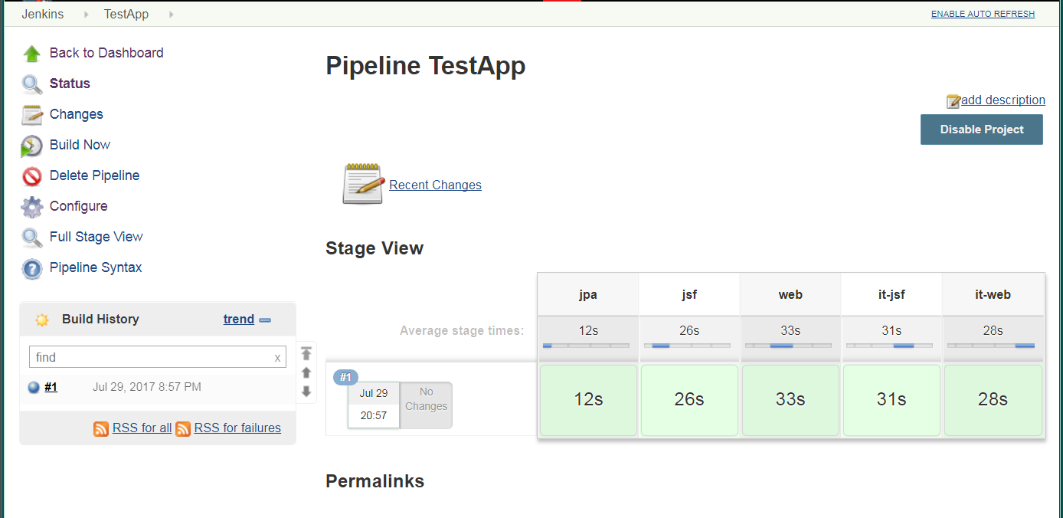

The general steps to accomplish this are:
- Create a pipeline project and point to the source repository
- Run the initial job and watch the pipeline progress

- Test that Jenkins is running by opening a web browser to http://localhost:8080.

- In the main Jenkins view create a New Item named TestApp which will be a Pipeline job. You can see these items in the pipeline graphic in the introduction.
- Select: New Item
- Enter the name: TestApp
- Select Pipeline. Click OK.

- You are now on the TestApp configuration screen. This is where we will get the build started and build our first artifact.

  - The builds will be manual so don’t define a schedule.

  - In the Pipeline box define the properties for the pipeline build process. When you select the SCM you will have an error until you enter the repository URL. Once the repository URL is entered and you leave the field, the error will be resolved if the URL is correctly entered.
    - Select Pipeline from SCM Script
    - Select Git for the SCM
    - Set Repository URL to
  - For Windows: C:\Setup\git\course-pipeline
  - For Mac: ~/setup/git/course-pipeline

  - The remaining options will be left as the defaults. We will use the master branch and the file that will control the build is the default jenkinsfile.

  - Save the changes.

  - Since there has been no build yet, the Stage view will only show a status No data available. This Pipeline has not yet run.

- Click the Build Now button. As the build progresses the screen will show the results of each stage. If the screen is not set to refresh automatically, the screen can be refreshed using the browser Reload button which is usually a circular arrow icon.

- While the build is running examine the jenkinsfile build file. You can open it in any editor. Read the file and the comments explaining what the build stages and steps are.

- Eventually, after a few minutes, the build will finish. When the build finishes, you will see five stages with a timing on the top and a blue bar showing the relative time of each stage and the results in light green on the bottom.

- The Stage View introduces a new way to view the log files. Click the Full Stage View link on the right-hand side of the TestApp main project page. Position the mouse over the green results portion of any stage. A popup menu with the title Success will show. Click the logs button. Another popup menu will show the list of the steps in the stage and allow the selection of a log to view. Click the downward pointing triangle on the first step Git -- followed by the URL of the git repository and view the log results for that step of the stage.

- You have successfully built an application using Pipeline with code in Jenkins. Congratulations!

11: Build a Jenkins Pipeline View

Overview
In this lab, you will install the Jenkins Pipeline Plugin and configure a Pipeline.

TestApp-build-jpa is a utility jar that is used by the web applications. Successfully building TestApp-build-jpa will trigger TestApp-jsf and TestApp-web. If the unit tests and other checks pass, then TestApp-deploy-jsf and TestApp-deploy-web will be triggered. Their completion will trigger TestApp-integration-jsf and TestApp-integration-web to run the integration tests on the deployed application. If all goes well, every job will be green.

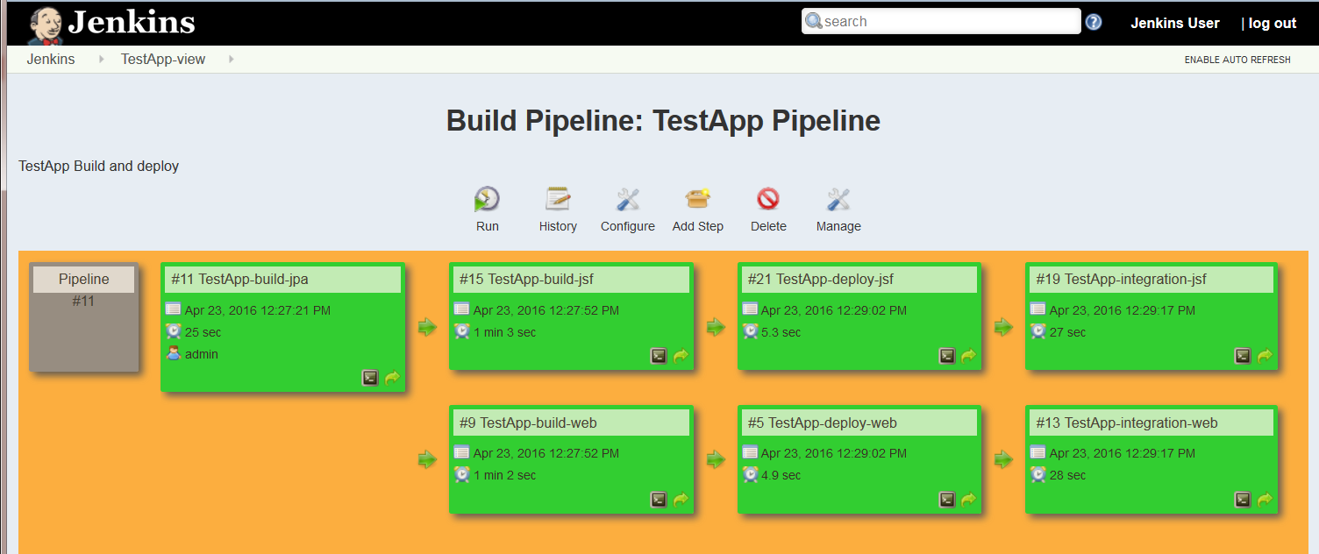

The general steps to accomplish this are:
- Create a build pipeline view
- Create a job for a shared library
- Create jobs to build two web applications
- Create jobs to deploy the applications to Tomcat
- Create jobs to perform integration tests on both apps
- Add to the build pipeline view
- Run the initial job and watch the pipeline progress

- Stop any Jenkins instances that are running, and restart Jenkins on the Tomcat server. The Tomcat server is required for this lab. For details on how to run Jenkins from within Tomcat, revisit the last section of Lab 1.
- Test that Jenkins is running by opening a web browser to the following URL. Notice that /jenkins follows the 8080 port number. This change is due to the fact that Jenkins is being hosted on the Tomcat server.
http://yourHostName:8080/jenkins.

- Click the Manage Plugins link. Click the Available tab and search for and select:
- Build Pipeline Plugin.
- Copy Artifact Plugin.
Click the download now and install after restart button.

- After some time, the download of the plugins will finish. Stop and restart Jenkins. Now, it is possible to define a Pipeline job.

- Return to the main Jenkins page and add five New Items. You can see these items in the pipeline graphic in the introduction. These are Maven projects because they will run a build from the pom.xml so we won’t have to add that as a build step. We will need to specify the goal and will do so in a later step.
- Select Maven project. Click OK → Back to Dashboard.
- Use these names:
- TestApp-build-jpa
- TestApp-build-jsf
- TestApp-build-web
- TestApp-integration-jsf
- TestApp-integration-web

- Return to the main Jenkins Page and add two more New Items. These are configured as Freestyle because we don’t need to do a Maven build step. This is a simple copy step.
- Select Freestyle project
- Use these names:
- TestApp-deploy-jsf
- TestApp-deploy-web

- Return again to the main Jenkins page and select TestApp-build-jpa and select Configure. This is where we will get the build started and build our first artifact.
  - Under Source Code Management select Git.
  - Set Repository URL to:
  - For Windows: C:\Setup\git\course-jpa
  - For Mac: ~/setup/git/course-jpa

  - Uncheck Build whenever a SNAPSHOT dependency is built. If this is left checked then the pipeline will attempt to build it twice and it will show up as two objects in the pipeline view.

  - The builds will be manual so don’t define a schedule.

  - Under Pre Steps click Add pre-build step.
    - Select Invoke top-level Maven targets
  - Set Maven Version to Maven 3.3.9
  - Set Goals to clean install

  - Under Post Steps click Add post-build step.
  - Select Trigger/call builds other project.
  - Enter TestApp-build-jsf, TestApp-build-web

  - Save the changes.

- Configure TestApp-build-jsf. This will build our second artifact, the web application using JSF technologies.
  - Under Source Code Management select Git.
  - Set Repository URL to:
  - For Windows: C:\Setup\git\course-jsf
  - For Mac: ~/setup/git/course-jsf

  - Uncheck Build whenever a SNAPSHOT dependency is built.

  - Under Pre Steps click Add pre-build step.
    - Select Invoke top-level Maven targets
  - Set Maven Version to Maven 3.3.9
  - Set Goals to clean install

  - Under Post Steps click Add post-build step.
    - Select Trigger/call builds other project
  - Enter TestApp-deploy-jsf

  - Save the changes.

- Configure TestApp-build-web. This is where we build our web project that uses the artifact built in the first project.
  - Under Source Code Management select Git.
  - Set Repository URL to:
  - For Windows: C:\Setup\git\course-web
  - For Mac: ~/setup/git/course-web

  - Uncheck Build whenever a SNAPSHOT dependency is built.

  - Under Pre Steps click Add pre-build step.
    - Select Invoke top-level Maven targets
  - Set Maven Version to Maven 3.3.9
  - Set Goals to clean install

  - Under Post Steps click Add post-build step.
    - Select Trigger/call builds other project
  - Enter TestApp-deploy-web

  - Save the changes.

- Configure TestApp-integration-jsf.
  - Under Source Code Management select Git.
  - Set Repository URL to:
  - For Windows: C:\Setup\git\course-jsf
  - For Mac: ~/setup/git/course-jsf

  - Uncheck Build whenever a SNAPSHOT dependency is built.

  - Under Pre Steps click Add pre-build step.
    - Select Invoke top-level Maven targets
  - Set Maven Version to Maven 3.3.9
  - Set Goals to: compiler:testCompile failsafe:integration-test

Note: The reason these goals are used is that there is no need to build and install a new version of the project since that was done in previous steps. All this step is going to do is execute the integration tests for the project which require the application already deployed into a running application server. To run the test, the test classes need to be available at runtime.

  - No Post Steps need to be defined for this project.

  - Save the changes.

- Configure TestApp-integration-web.
  - Under Source Code Management select Git.
  - Set Repository URL to:
  - For Windows: C:\Setup\git\course-web
  - For Mac: ~/setup/git/course-web

  - Uncheck Build whenever a SNAPSHOT dependency is built.

  - Under Pre Steps click Add pre-build step.
    - Select Invoke top-level Maven targets
  - Set Maven Version to Maven 3.3.9
  - Set Goals to: compiler:testCompile failsafe:integration-test

  - No Post Steps need to be defined for this project.

  - Save the changes.

- Configure TestApp-deploy-jsf.
  - Under Build, click Add build step to Copy artifacts from another project.
  - Set the project name to TestApp-build-jsf

  - Click Add build step again.
  - For Windows: select Execute Windows batch command
copy %WORKSPACE%\com.example\course-jsf\0.0.1-SNAPSHOT\course-jsf-0.0.1-SNAPSHOT.war "C:\Program Files\Apache Software Foundation\Tomcat 8.5\webapps\course-jsf.war"

  - For Mac: select Execute shell
cp ${WORKSPACE}/com.example/course-jsf/0.0.1-SNAPSHOT/course-jsf-0.0.1-SNAPSHOT.war /Library/tomcat/webapps/course-jsf.war

This will copy the artifact just copied in step A to the running instance of Tomcat to deploy it.

  - Click Add build step again.
    - Select Trigger/call builds on other projects
    - Set Projects to build to: TestApp-integration-jsf

- Configure TestApp-deploy-web.
  - Under Build, click Add build step to Copy artifacts from another project.
  - Set the project name to TestApp-build-web.

  - Click Add build step again.
  - For Windows: select Execute Windows batch command
copy %WORKSPACE%\com.example\course-web\0.0.1-SNAPSHOT\course-web-0.0.1-SNAPSHOT.war "C:\Program Files\Apache Software Foundation\Tomcat 8.5\webapps\course-web.war"

  - For Mac: select Execute shell
cp ${WORKSPACE}/com.example/course-web/0.0.1-SNAPSHOT/course-web-0.0.1-SNAPSHOT.war /Library/tomcat/webapps/course-web.war

  - Click Add build step again.
    - Select Trigger/call builds on other projects
    - Set Projects to build to: TestApp-integration-web

- Above the list of projects click the + sign next to the All tab.
  - Enter TestApp-Pipeline for the name and select the Build Pipeline View radio button.
  - Click OK to create the pipeline view.
  - Click the Configure button and select TestApp-build-jpa for the Select Initial Job dropdown.
  - Click OK and the screen will refresh to show the job hierarchy shown on the first page of this exercise.
  - Compare the jobs to the picture at the beginning of the lab. Everything should be blue initially as none of the jobs have run yet.

- Click the Run button. As each job is executed, it will turn from blue to yellow to green. Yellow indicates the job is in progress. If the job turns red, then there was an error. Fix the error and rerun the pipeline.

- Eventually all the jobs will turn green as the build cascades.

Note: The first time you run this, two build jobs will stay yellow. When you look at the console output it is because the build is Unstable. This happens because the build jobs test a deploy that is being done by the deploy jobs which at that point have not run yet. When you run it again, all the files are in place and it will run successfully.

